Home Assignment - Enhance the Existing Resume RAG Application by implementing the following features:
- Re-ranking of retrieved resumes
- Deduplication of repeated results
- Summarization of the final results
- Complete end-to-end pipeline integration
- Display all relevant results clearly on the UI

Customize the application based on your organization’s branding, including:
- Organization name and logo
- Brand theme and colours
- Professional UI layout
- Responsive design
- Loading, success, validation, and error messages
- Any other relevant organization-specific enhancements

After completing the implementation, test the complete end-to-end application.
Submit the following items in both the WhatsApp group and your GitHub repository:
Assignment completed and published to GitHub - https://github.com/Srividhya0505/Resume_Rag

Resume ingestion Validation
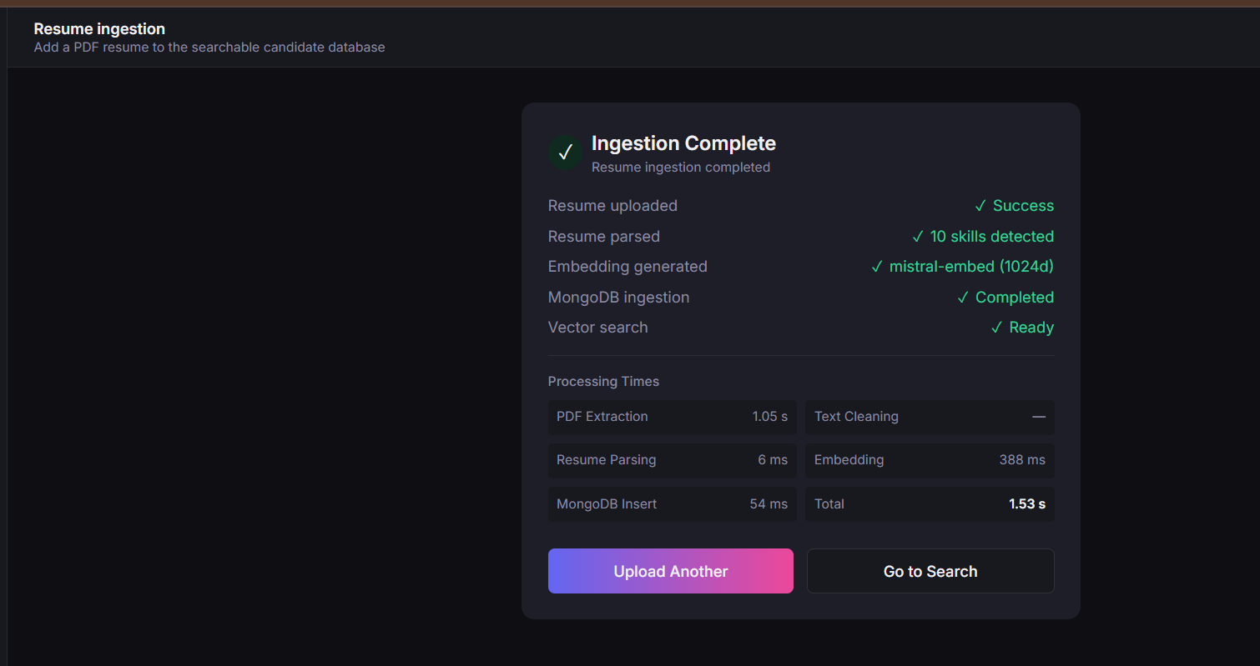
Search – Vector Search with input Srividhya
Result – Re-ranked, de-duplicated (forgot to take screenshot before de-duplication, kindly excuse), added option to summarize retrieved context
Prompt : Add deduplication in the background to the existing framework and make it as automatically applied. Also add summarization of the final results. The heading should be Final Results with a Summarize retrieved context

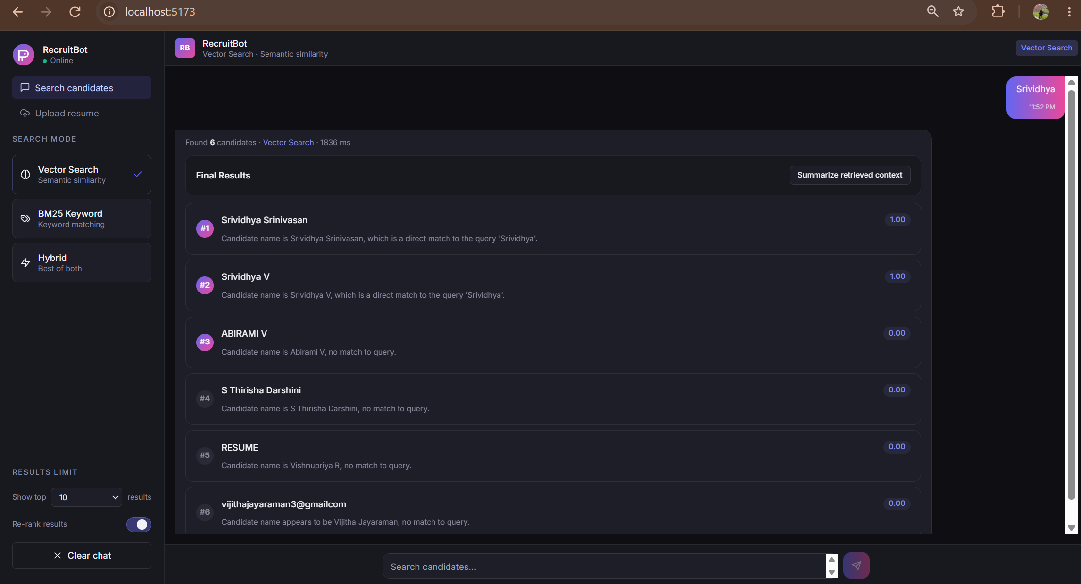

Summarized Context from the Vector search
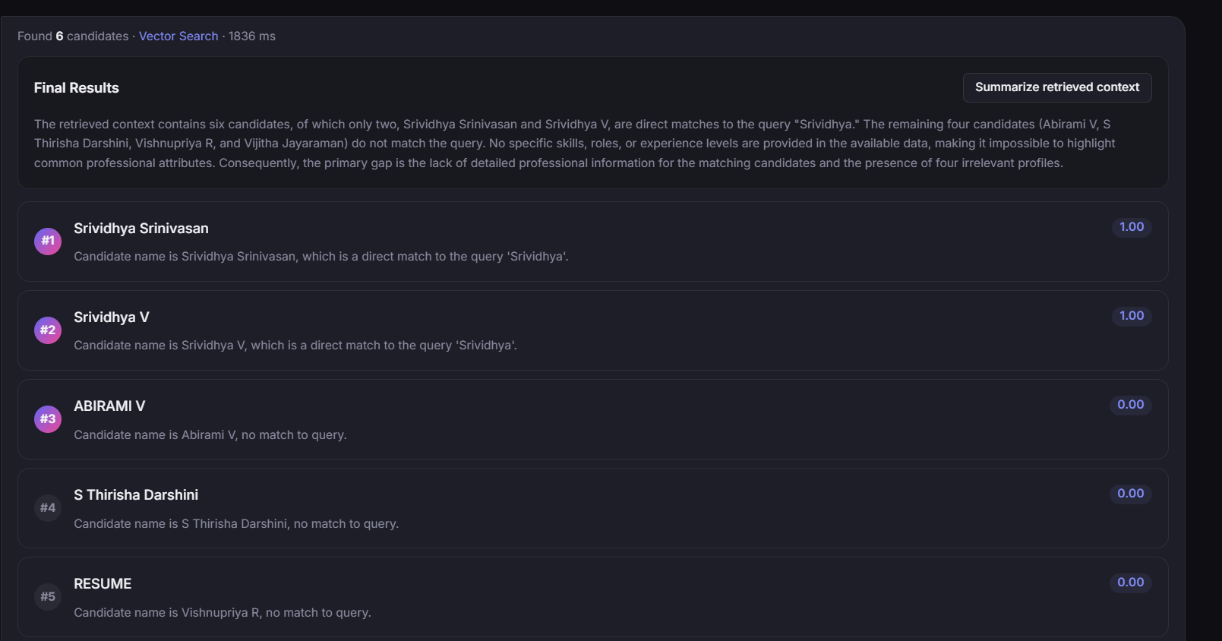
Clear chat cleared the existing search results
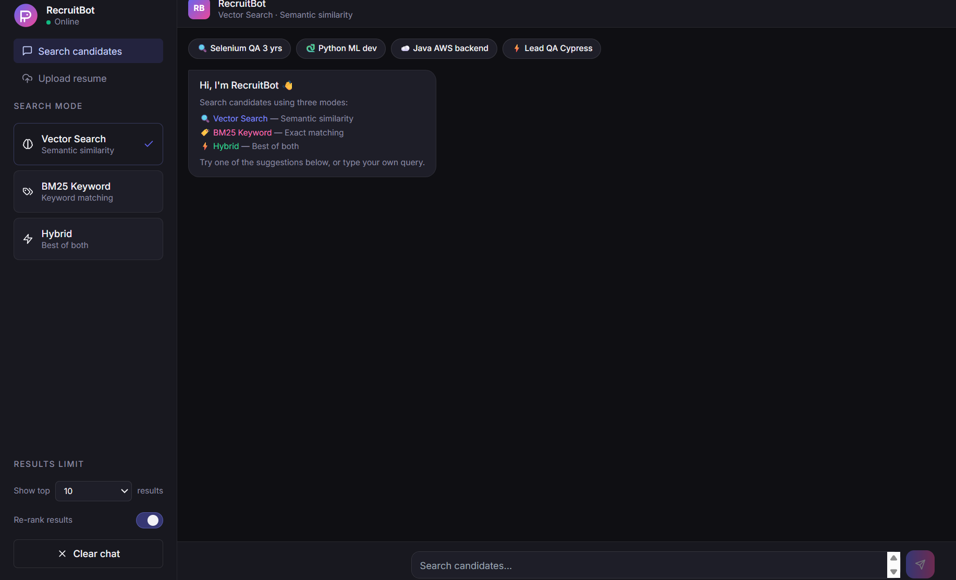
BM25 keyword search with summarized data
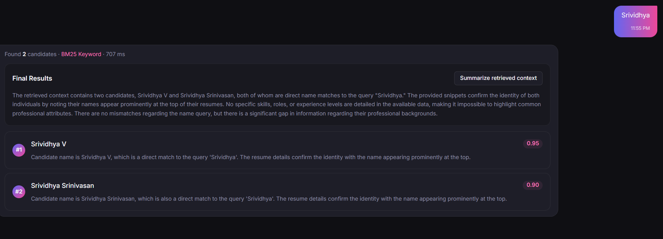

Hybrid search
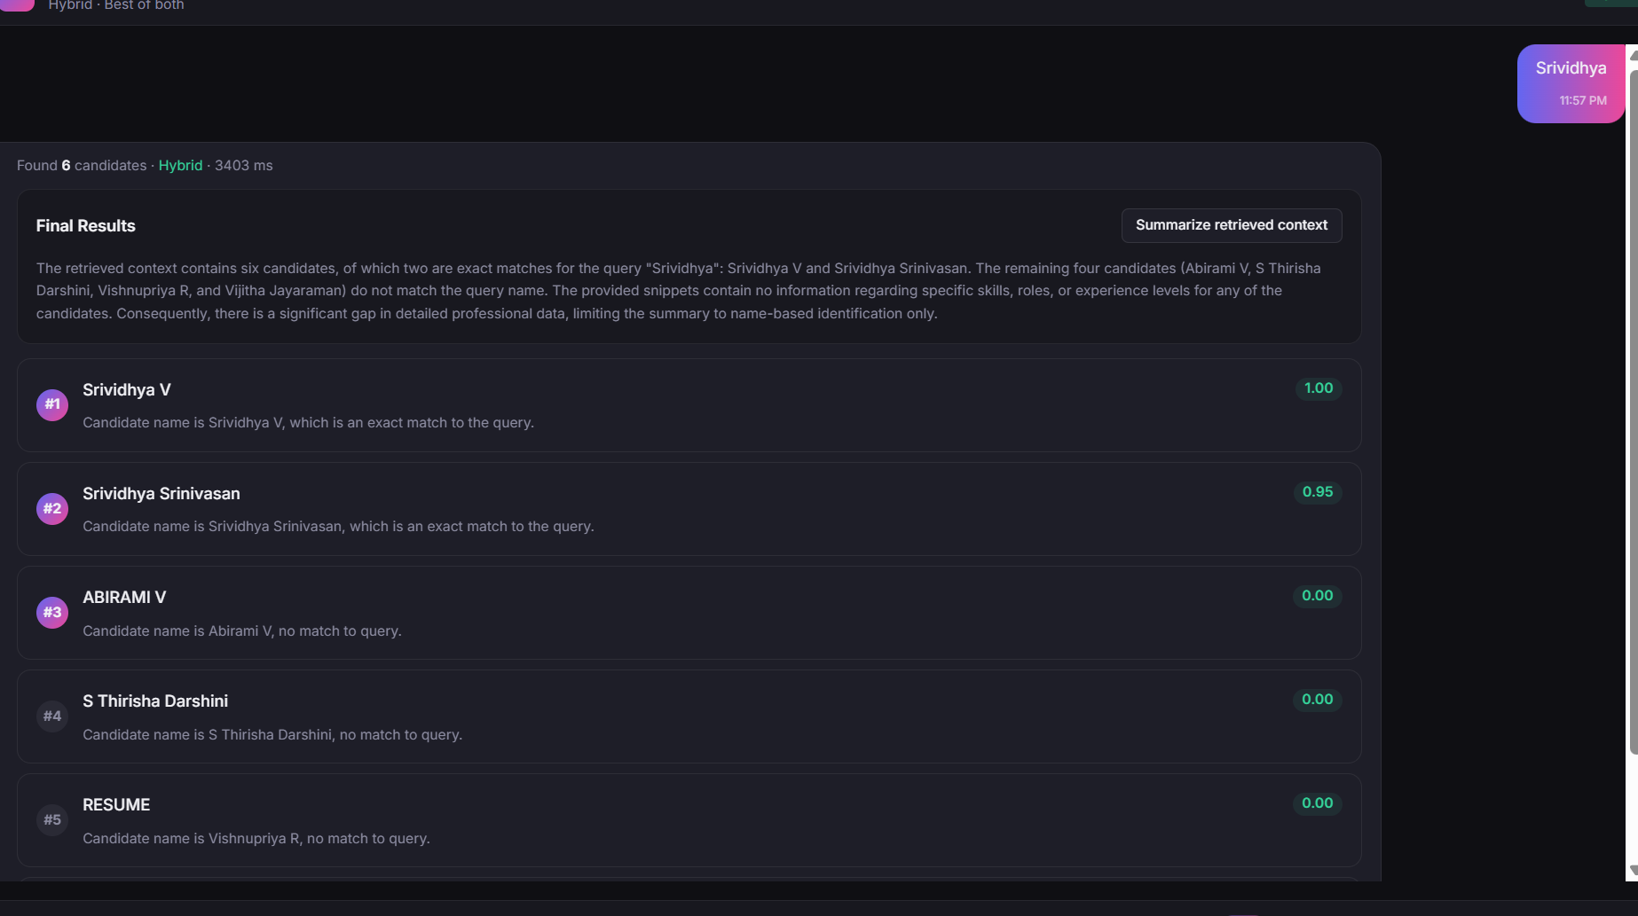
Re-ranking disabled – Hybrid – since re-ranking was disabled, result given based retrieval score
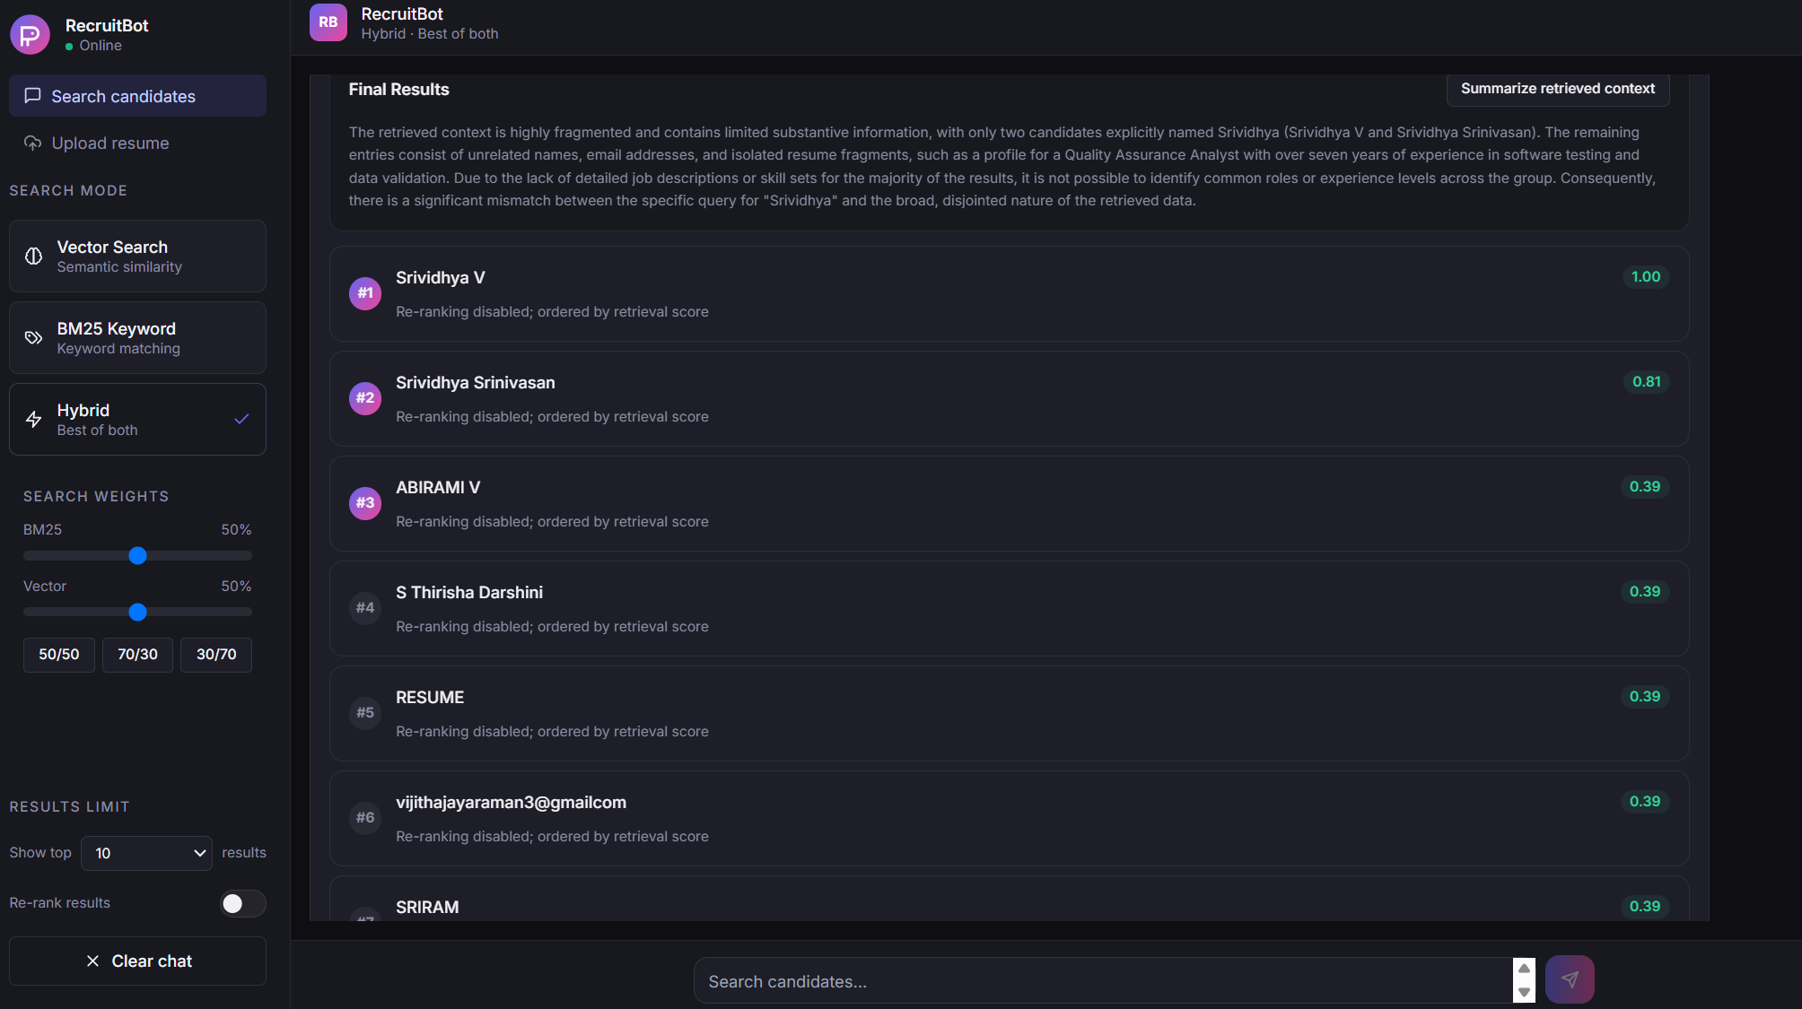
Re-ranking enabled for Hybrid with deduplication

Summarization context for each candidate – UI Option Added to enable/disable
Prompt - Make changes to give brief candidate summary along with each retrieved resume and keep it as an UI option to enable/disable and also in the final results for the overall summary
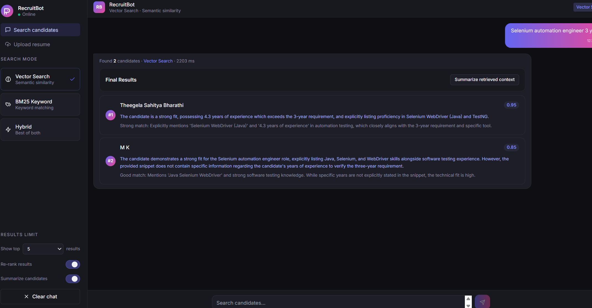
Overall summarization is also be added
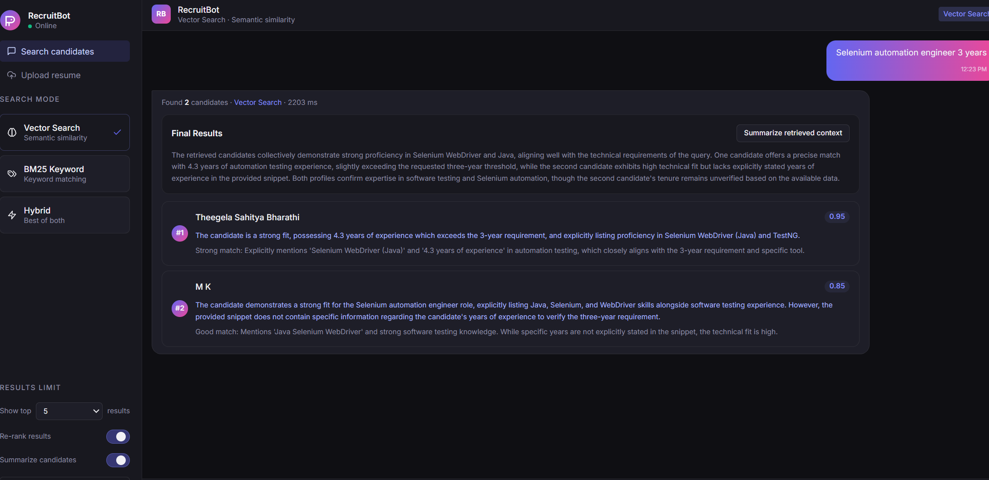

Enabling both individual and overall summary
Prompt:
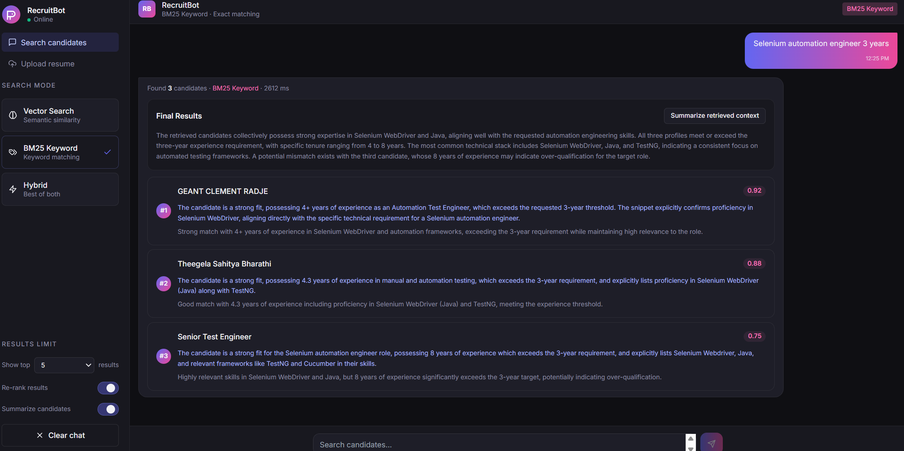
Prompt
I want the background to be changed as like attached screenshot and add the attached logo in the screen and fit it as needed

End Result:

